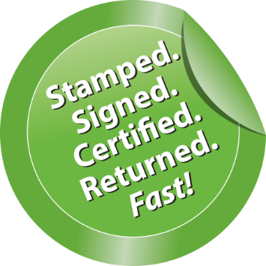

**eCertification**

**How does it work?**

To request an**eCertified** copy, simply go to the above QR code or <https://ecert.gsccca.org> to create an account. Once registered, log in to get started:

Follow the steps to submit a request for an **eCertified** document.

1. Click Submit a New Request at the top, right corner of the page
2. Select the county where the record is located
3. Select the document type
4. Select Continue to Submit the Request
5. Complete all required fields and select Submit request

Once the Clerk’s office processes the request, payment authorization will be required. When the Request Status is Awaiting Payment Final Authorization, submit final payment authorization by clicking on Awaiting Payment Final Authorization and following the prompts. Once payment authorization is received and finalized by the Clerk’s office, a final email will be sent containing an authentication link which also includes the purchased **eCertified** copy of the requested document.

A purchased **eCertified** copy of a document may be downloaded and stored for future use, allowing customers to maintain their own documents for multiple uses and printing.

The Clerk of Superior Court’s Office is pleased to announce the new **eCertification** services that provide users the ability to electronically request certified Court and Real Estate Records 24 hours a day, 365 days a year.

**What is eCertification?**

**eCertification** is a software used by the Clerk’s office to generate tamper-proof and self-validated certified copies of Court Records and Real Estate Recordings. Customers can purchase electronically certified records from the convenience of their home, their smart phone, or anywhere they have internet access 24-7, and upon processing by the Clerk’s office, receive them as secured PDFs via email or online at <https://ecert.gsccca.org>.

A trip will no longer be required to the Clerk’s office to have a paper copy certified. The public can now access this new online service by visiting the Clerk’s website.



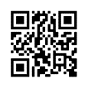

If you have any questions, feel free to call us at (706)672-4416.

CLERK OF SUPERIOR COURT

KYEMESHIA T. GIBSON