Filing Activity Notification System (FANS) | - MERIWETHER  - County Superior Court Clerk’s Office  - 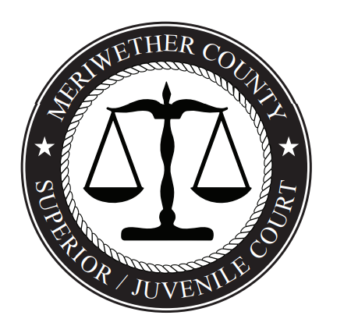
Meriwether County Superior Court Clerk’s office in conjunction with the Georgia Superior Court Clerks’ Cooperative Authority (GSCCCA) is pleased to offer the Filing Activity Notification System, FANS, providing Georgia citizens with tools to monitor activity regarding their property and records.  FANS is a free, voluntary, opt-in program that can be used to send electronic notifications of filing activity to individuals who create notifications in the system. The notifications generated by this system are not guaranteed to be accurate or complete, and use of the system is subject to an acknowledgment of these conditions.  To get started, go to https://fans.gsccca.org and follow the prompts. If you have any questions or concerns regarding the FANS, please contact the Georgia Superior Court Clerks’ Cooperative Authority customer support at 1-800-304-5174 or help@gsccca.org.  We hope you find this service to be beneficial as Meriwether County Superior Court Clerk’s office continues to explore and implement new ways to improve services delivered to the citizens of Meriwether County. | Clerk of Superior Court  Kyemeshia T. Gibson  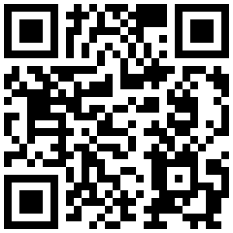  GSCCCA Customer Support  1-800-304-5174  help@gsccca.org

